Christian Seyoum

1)

#include <iostream>

using namespace std;

int main()

{

cout << "Hello, world." << endl;

}

Output

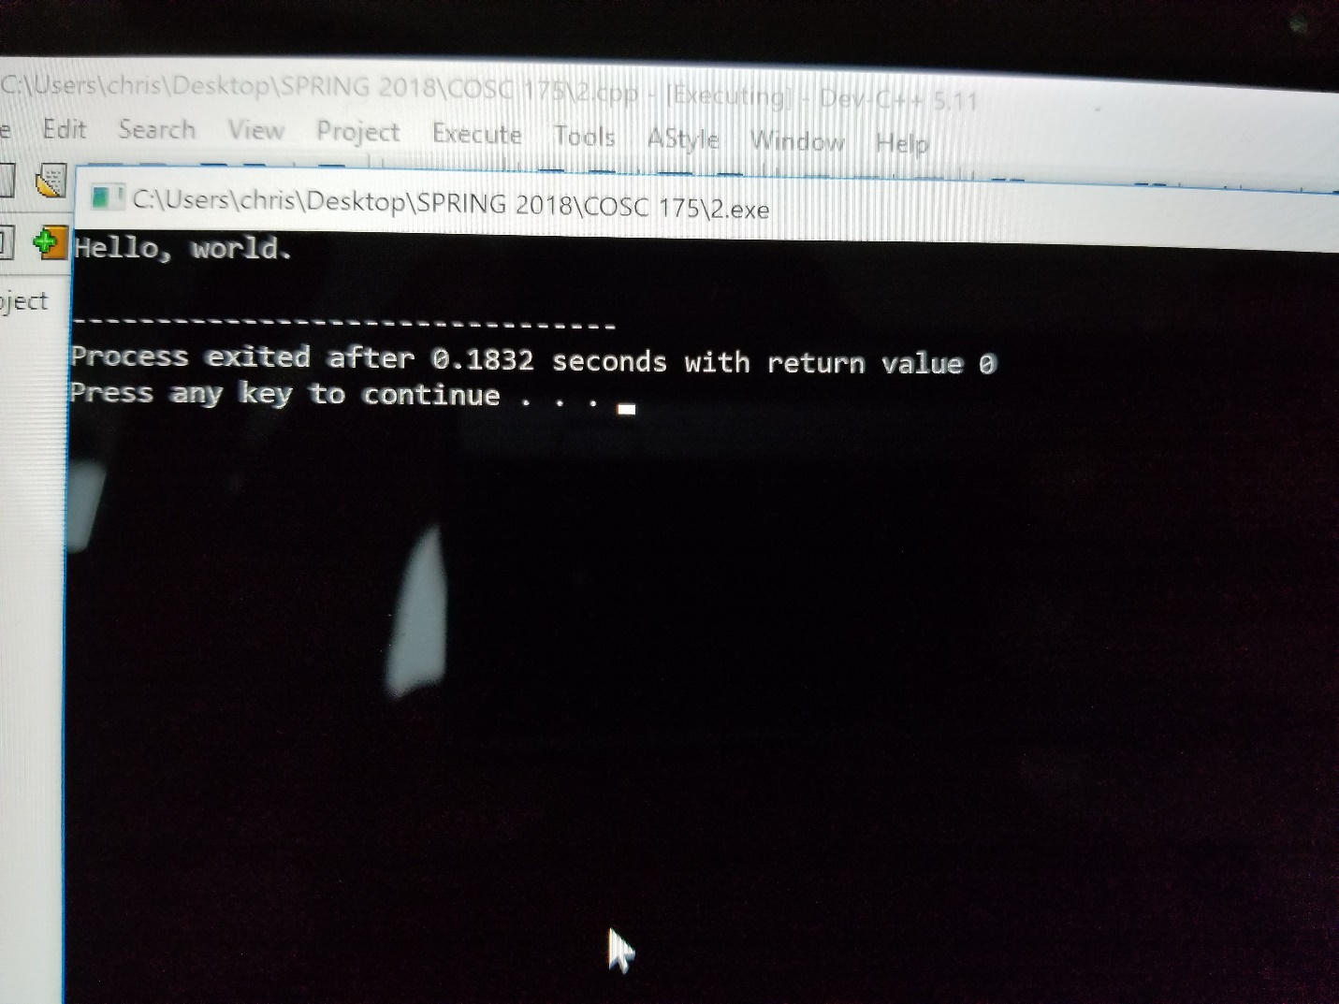

**Answers to question**

1. When we run this code, we will be greeted with, “Hello world.” The output is simply a statement!
2. There are no errors on this code.
3. The compiler converts the code to a language a computer can process. Also the compiler checks your work by looking at the library and makes sure there are no mistakes in any of the lines of code.

2)

//this code will do divition of 2 numbers added together by one number

#include <iostream>

using namespace std;

int main()

{

float num1;

float num2;

float num3;

float ans;

cout << "Enter three numbers, the first two numbers should be the numbers you with to add. The last number will be the number you will be dividing the first two by!" << endl;

cin >> num1 >> num2 >>num3;

ans = (num1 + num2)/num3;

cout << "The answer is " << ans;

}

output

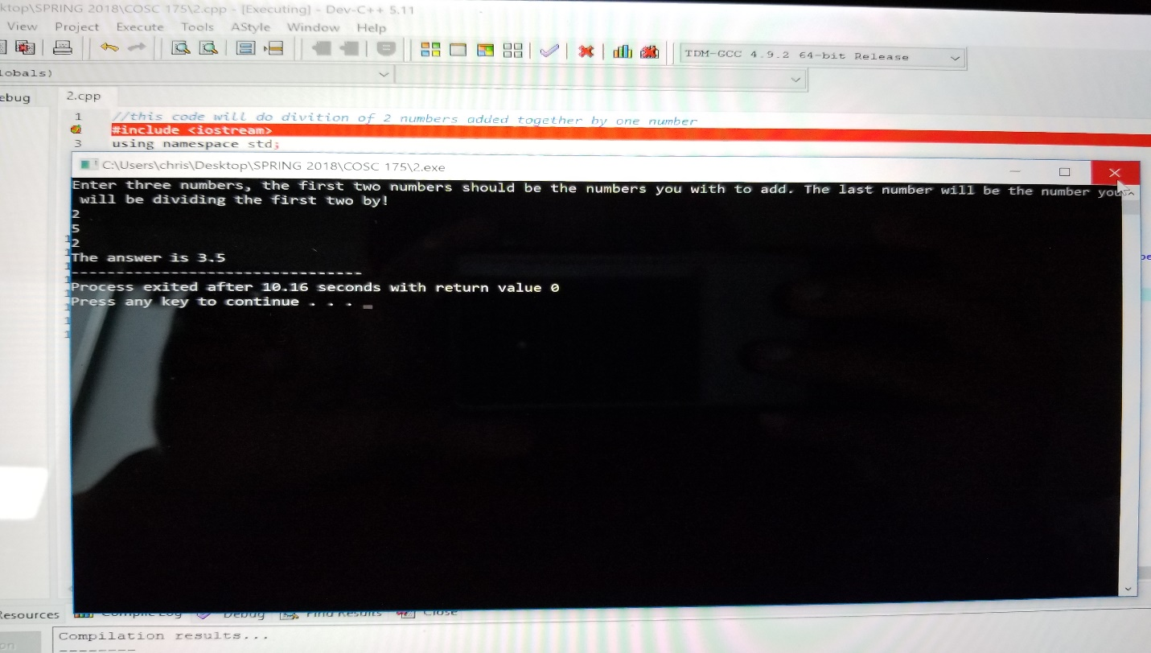

**Answers to question**

1. When we run this code, we will be asked to enter 3 numbers. Using this 3 numbers, (num1,num2,num3). The program process it and displays the following answer based on the numbers put in. answer= (num1 + num2)/num3
2. There are no errors on this code.
3. The compiler converts the code to a language a computer can process. Also the compiler checks your work by looking at the library and makes sure there are no mistakes in any of the lines of code.

3)

#include <iostream>

using namespace std;

int main()

{

float num1;

float num2;

float avg;

cout << "Enter two numbers" << endl;

cin >> num1 >> num2;

avg = num1 + num2/2;

cout << "The average is " << avg;

}

Output

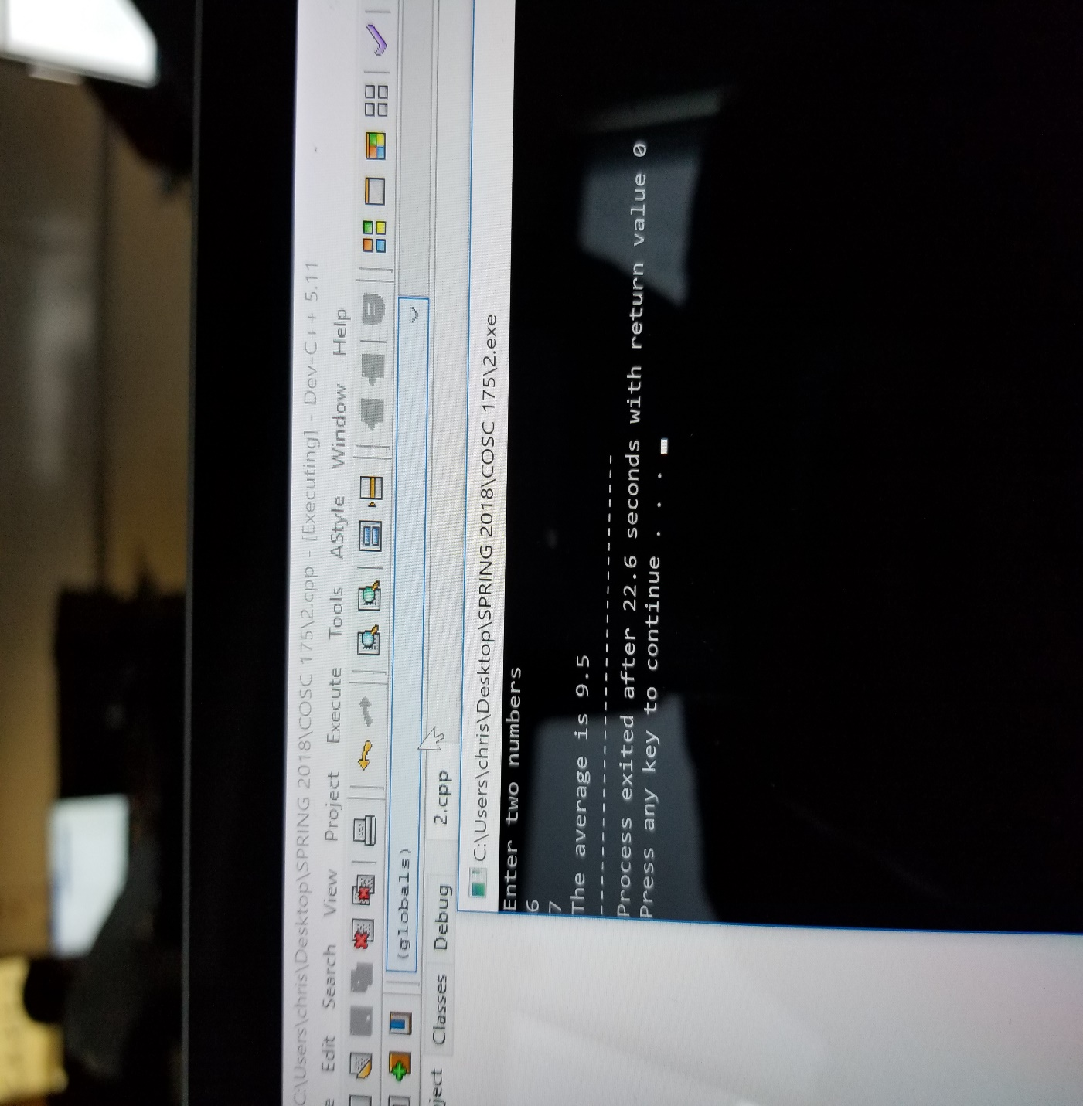

**Answers to question**

1. When we run this code, we will be greeted with, “Hello world.” The output is simply a statement!
2. There was an error, on the 6th line. This error was caused by the missing semicolon. This type of error would be a syntax error, due to the face that by not having the semicolon on the end to indicate that the line of code had ended we were violating the rules of the programing.
3. The compiler converts the code to a language a computer can process. Also the compiler checks your work by looking at the library and makes sure there are no mistakes in any of the lines of code.